

**Quiz Game**

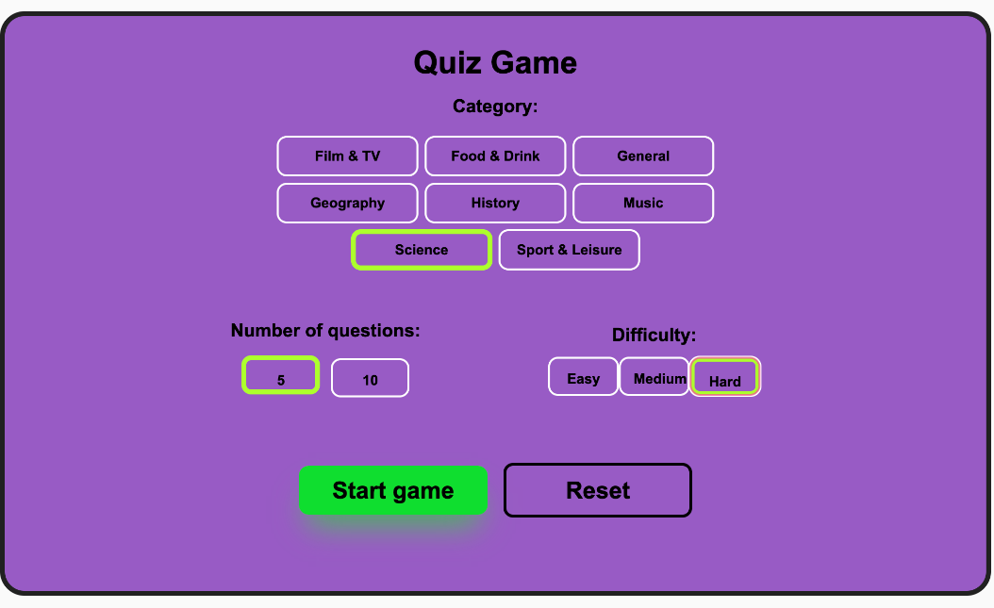

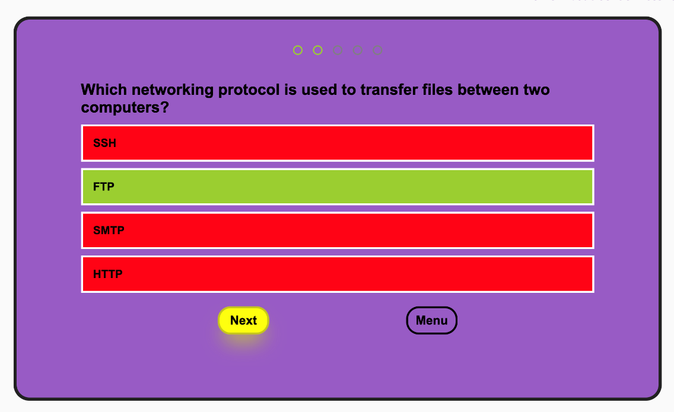

**Professor**

**Andrei Dascal**

**Student**

**Moldovan Rokk Melinda Iren**

**Table of contents**

Introduction…………………………………………………………………….3

1. What is a quiz? ………………………………………………………..4

a) Advantages of a quiz…………………………………………..4

2. Application design features…………………………………………..5

3. Did you know………………………………………………………………..6

a) Choosing the right tools……………………………………………7

b) Implementation on multiple screen………………………….9

4. Step by step application implementation………………………11

5. Additional enhancement……………………………………………….25

6. Bibliography……………………………………………………………26

# **Introduction**

**My Quiz Manager** presents professional background of the student located in a web application. This includes useful information that can assist in successfully acquiring a future job as a Front-End Developer.

The **purpose** of the project is to prove the programming skills gained throughout the “Front-End Developer” course attended at *Scoala Informala de IT*. This project will have an important role in certifying the main points learned in which the viewer will have a better understanding of the student’s mastery.

The **objective** of this project is to present a Quiz in an online environment along with the benefit of modern technology. This project is easily accessible, highly adaptable, and easy to use.

Tasks in accomplishing the final project:

* Performing application analysis in order to locate its deficiencies and the possibility of improvement;
* Identifying information that is required to be displayed to the clients, choosing the appropriate programming languages that will be used, and creating a task schedule;
* Presenting the functionality and performance of the project;
* Project development and efficiency.

# **What is a quiz?**

A quiz is the shortest, most common, and most casual form of evaluation.

**Purpose and scoring -** In a course setting, instructors most frequently give quizzes, which serve as a way for both teachers and students to see how well students understand the material. Quizzes help everyone focus on weak areas. Quizzes can be used as a brief assessment in education and similar fields to measure growth in knowledge, abilities, or skills using a scoring method. A scored quiz type allows you to assign a point value to each question answer in the quiz. At the end of the quiz, the score is tallied by adding up all point values assigned to the question answers that were selected by the quiz taker.

**Format -** Formats for quiz questions typically include fill-in-the-blank, multiple choice, and true or false. Quizzes don’t usually include interpretive, open-ended questions, such as essay questions.

**Length -** Quizzes are shorter than tests. Whereas a test may have 50 questions or more, a quiz typically has 10 or fewer questions.

1. a) Advantages of a quiz

* Quizzes are a fun method to learn
* Potential to support individual learning
* 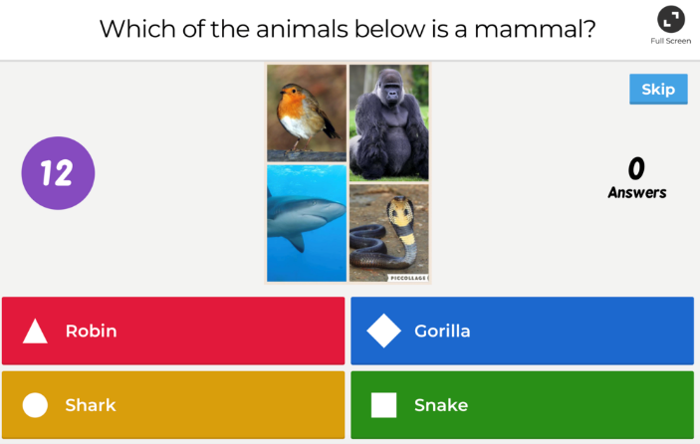Raise confidence
* Stress-free way of learning
* Icebreaker
* Constant learning
* Competitive learning
* Enthusiastic

Figure 1. Quiz example

**2. Application design features**

The application will be a single-page layout, which ensures the following:

* Easier to manage
* Optimized for mobile
* User-friendly
* All the content in one page
* Easy to change

**3. Did you know?**

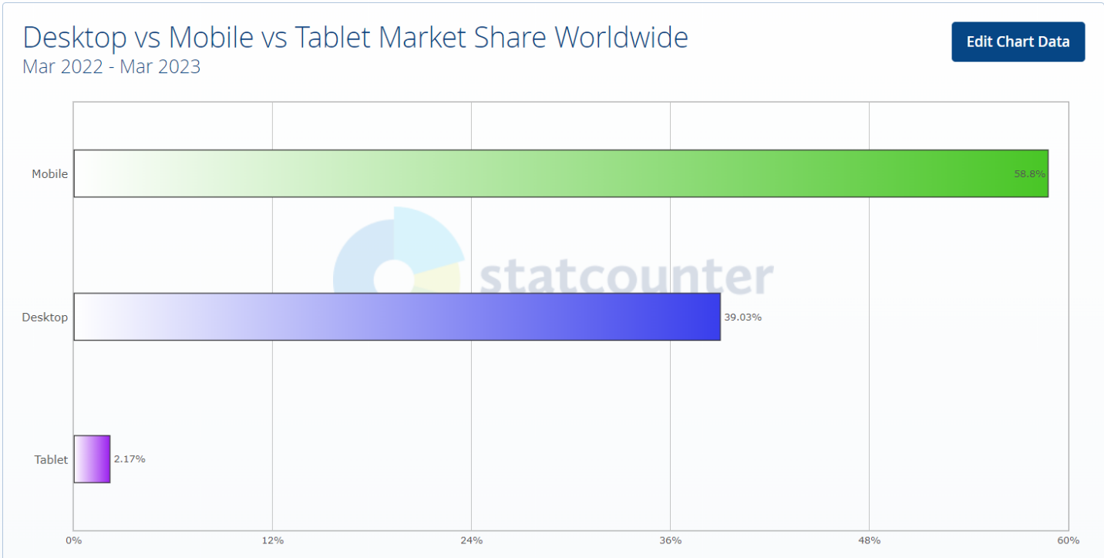

Figure 2. Device usage March 2022 - March 2023

According to StatCounter, almost **59%** of the users prefer Mobile, over Desktop and Tablet. When creating a website, it is essential to make sure it is highly functional on Mobile, Desktop and Tablet, because it will draw most of the audience to the website.

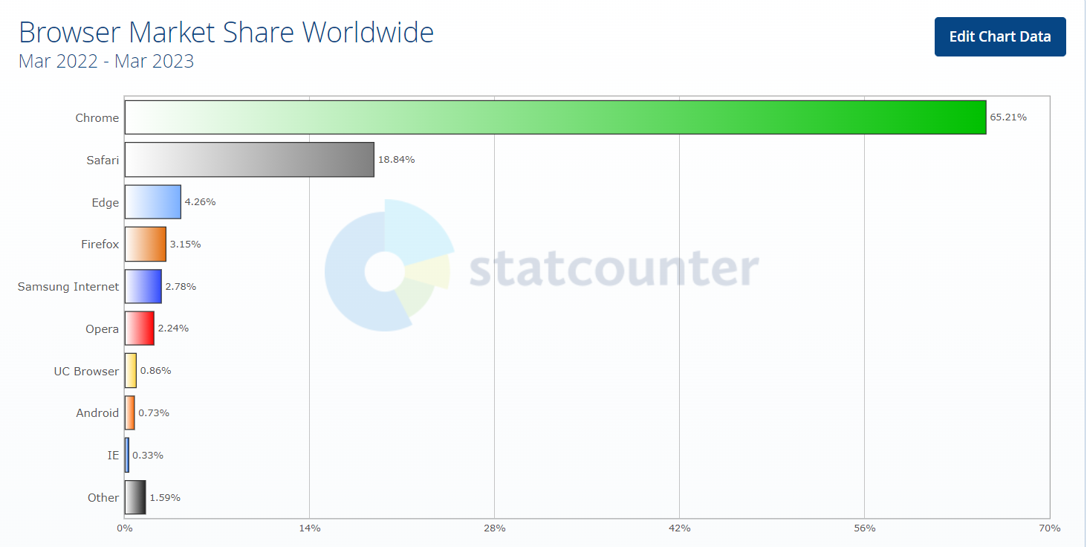

Figure 3. Browser usage March 2022 -March 2023

According to StatCounter, around **66%** of the users access the Chrome browser, making Safari the second choice. This means that testing is highly recommended to be performed on Chrome because most of the audience will be using Chrome.

**3. a) Choosing the right tools**

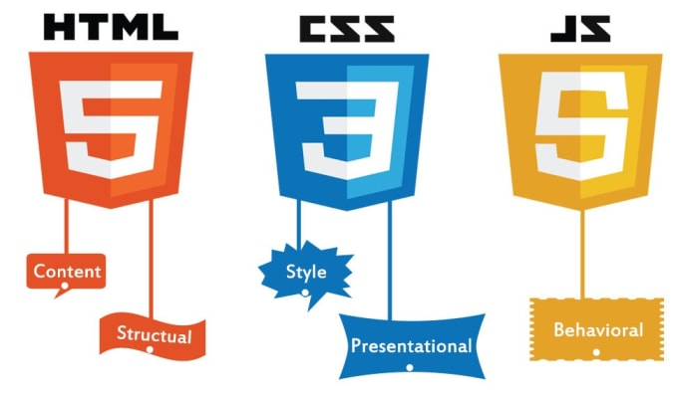

Figure 4. HTML, CSS, JavaScript logos

**HTML**, **CSS3** and **JavaScript** are the main programming languages required to build the application, **HTML** defines the structure and content of the page, **CSS** is used for the presentation and style such as colors, fonts, animations, dimensions, images, etc. **JavaScript** makes a page dynamic and behavioral.



Figure 5. Bootstrap logo

**Bootstrap** is an open-source **CSS framework**, directed at responsive mobile-first front-end development. It contains HTML, CSS and JavaScript-based design-templates for typography, forms, buttons, navigation, and other interface components.



Figure 6. Visual Studio Code logo

 **Visual Studio Code** is a code editor with support for development operations like debugging, task running, and version control. This is where code will be written for the application.



**Git** is a version-control system for tracking changes in computer files and coordinating work on those files among multiple users.

**GitHub** is a code hosting platform for version control and collaboration. This is where the application’s code will be securely stored.

Figure 7. Git & GitHub logos

**jQuery** is a fast, small, and feature-rich JavaScript library. It makes things like HTML document traversal and manipulation, event handling, animation, and Ajax much simpler with an easy-to-use API that works across a multitude of browsers.



Figure 8. jQuery logo

**3. b) Implementation on multiple screens**



Figure 9. Screen sizes

**400-600**

**900-600**

**900-1200**

**1200-1600**

This Quiz Game can be used on mobile too.

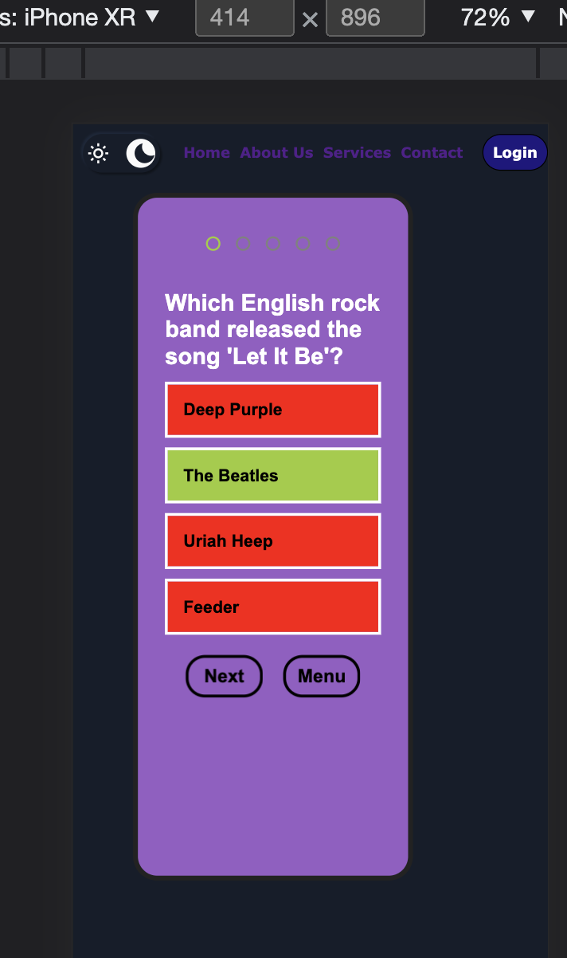

Figure 10. Example on iPhone XR

**4. Step by step implementation**

Started with the top bar (<div class=”navbar”>) in which I implemented a checkbox input for the dark mode, which on toggle switches between dark mode and light mode.

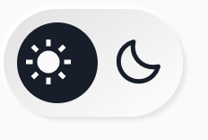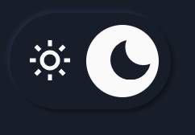

And then I added the rest of the items, an unordered list with anchor links, on the Contact anchor link it pops up a Contact form for feedback, and then I added the Login button.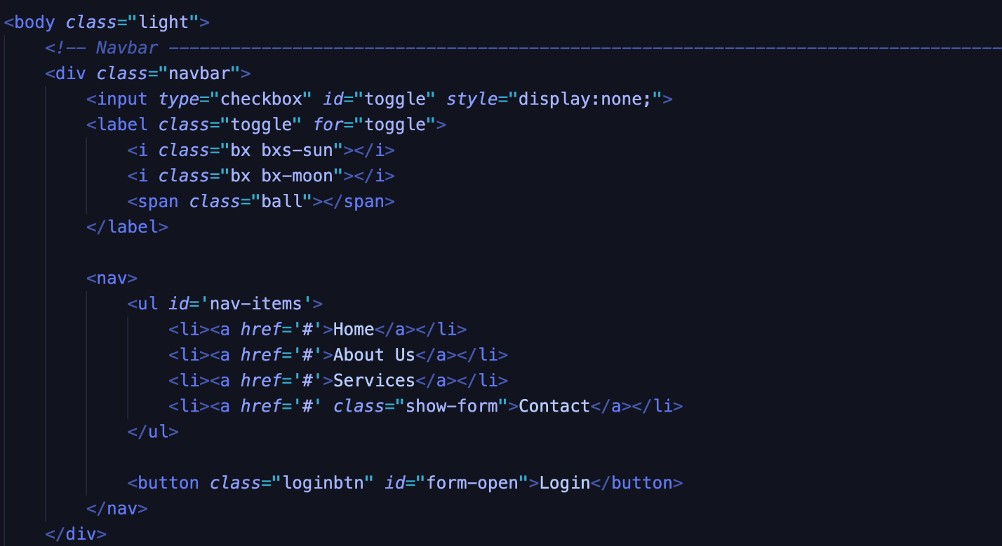

I added Icons in the input with Bootstrap, here is the wrapper div for the Login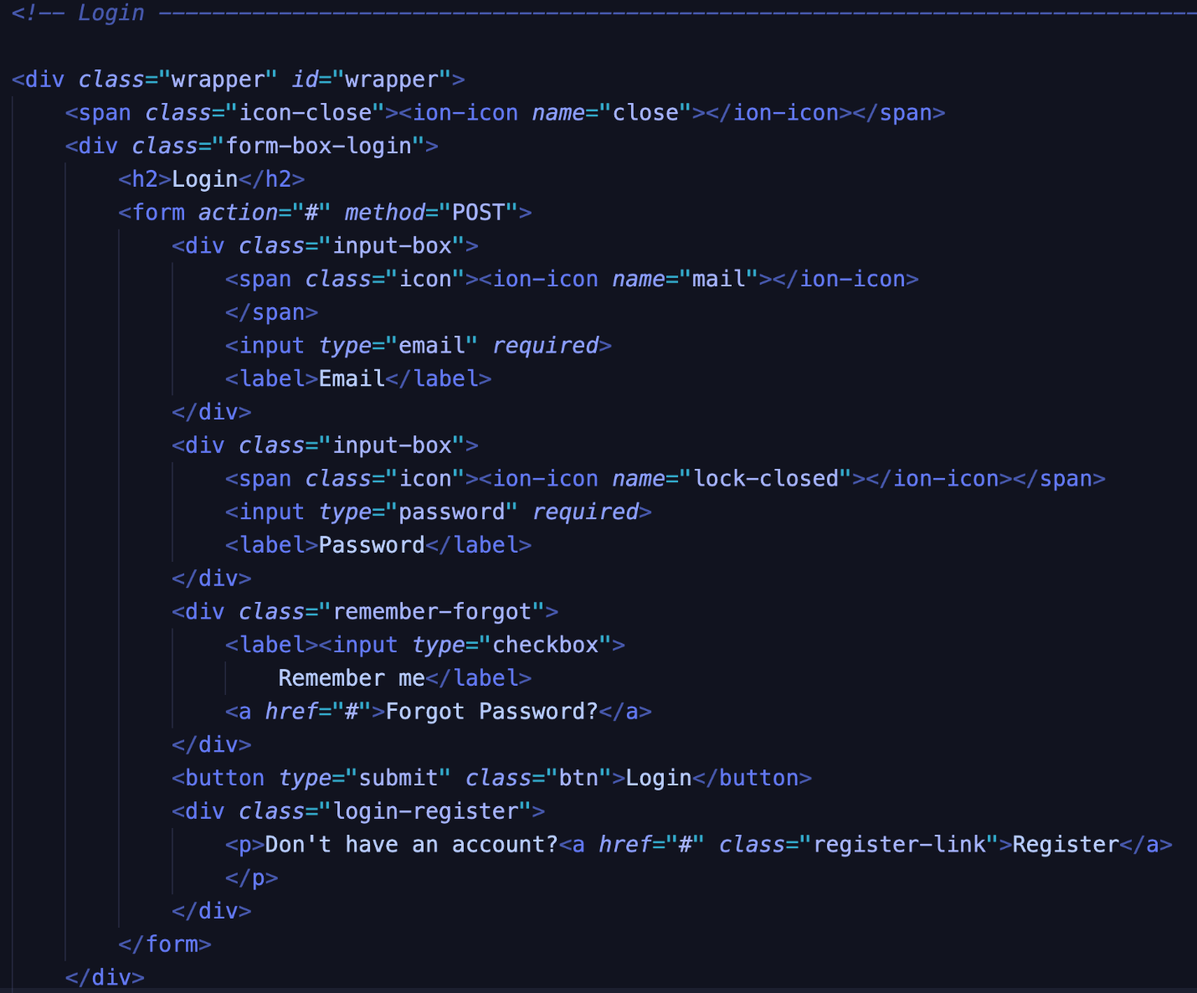:

Here is the register wrapper, this div is only showing when “Register” link is clicked:

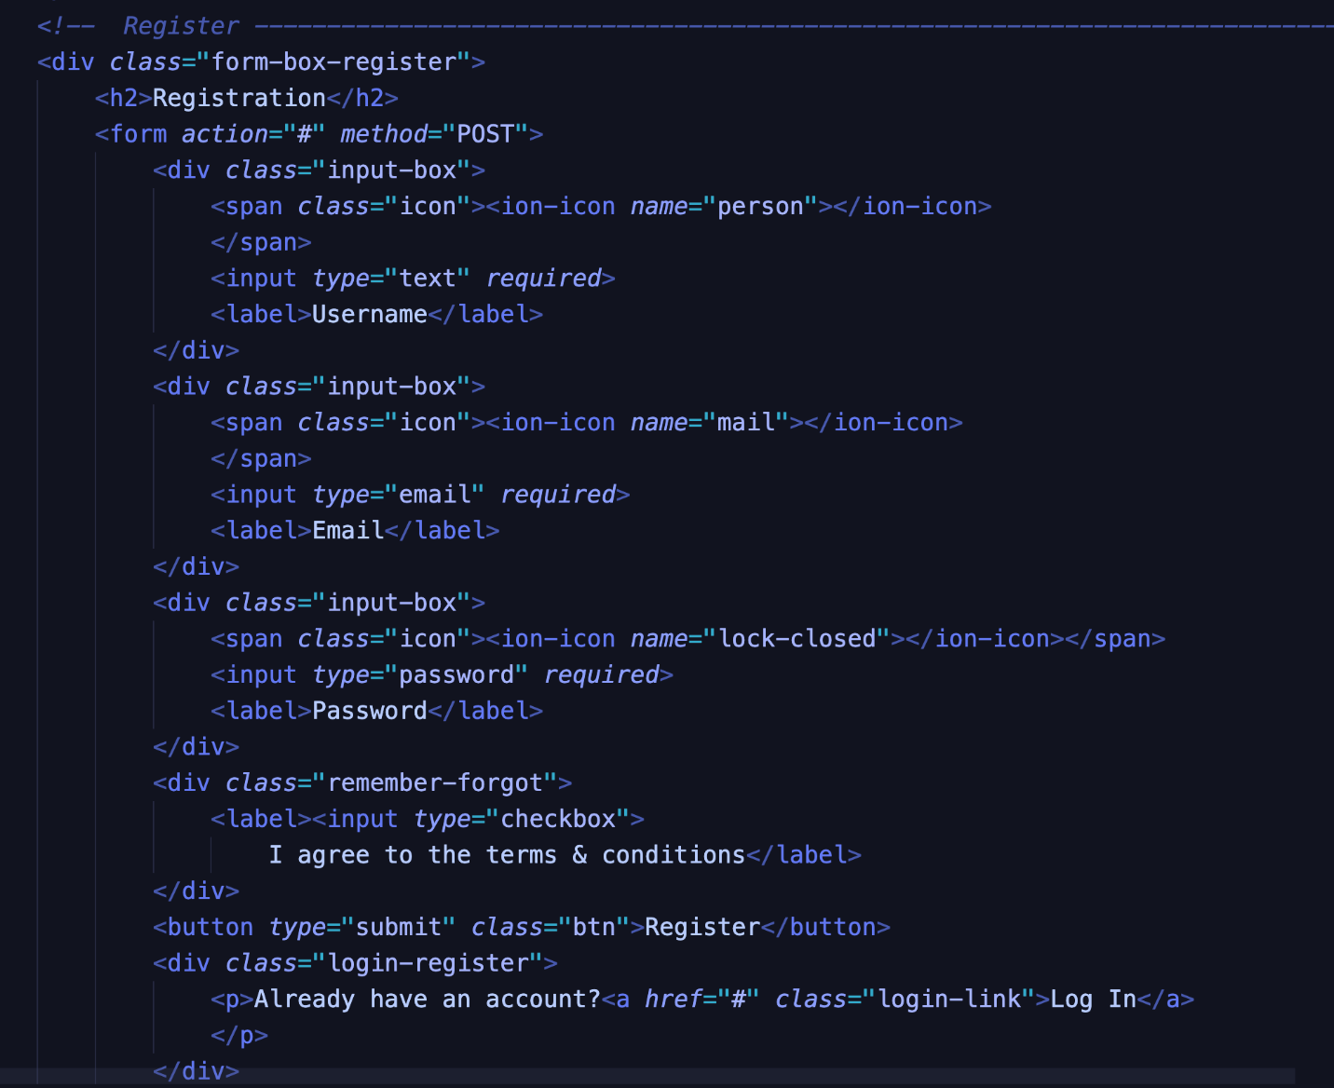

The feedback/Contact form which pops up when “Contact” link is clicked: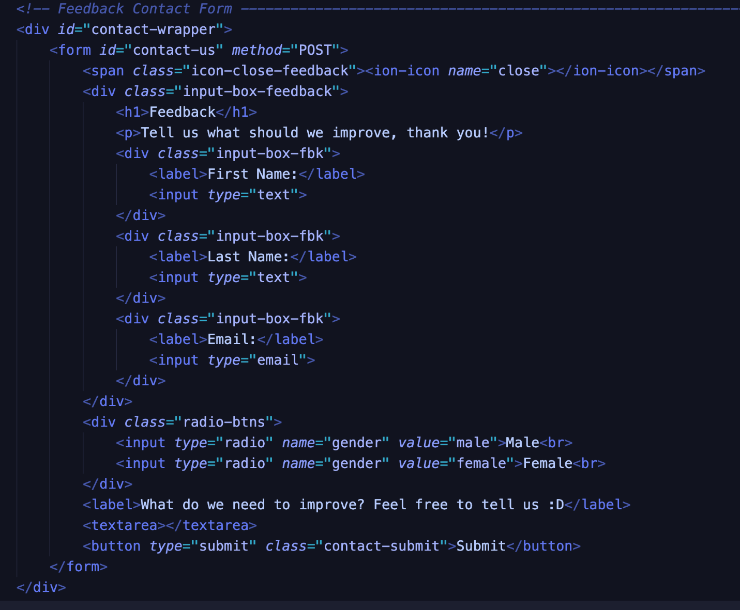

Quiz Structure

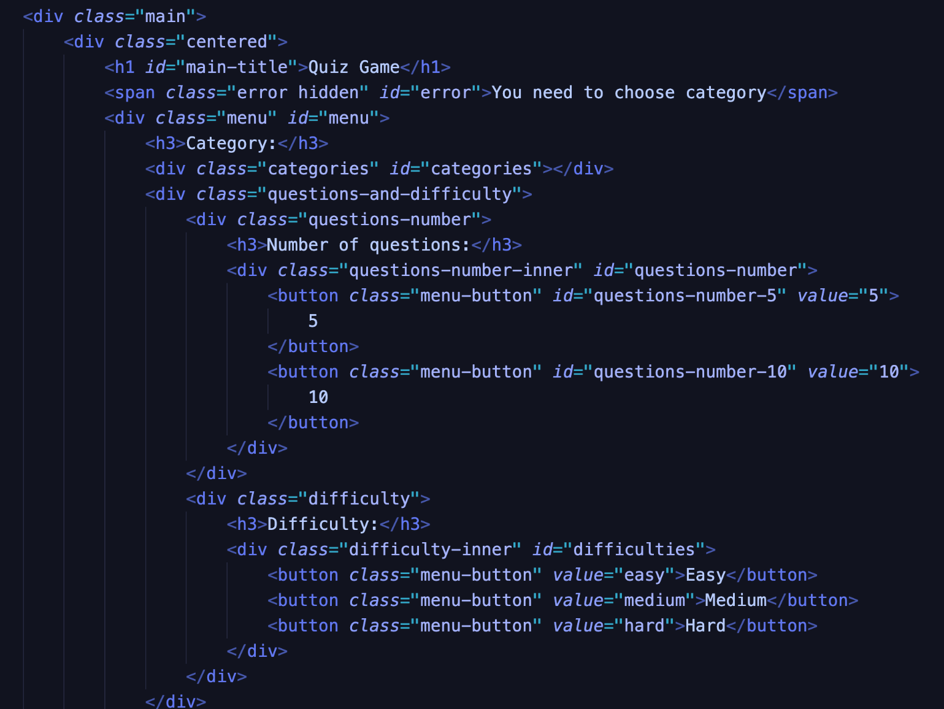

The JavaScript code in which I added functionality for the dark mode implementation.

I used jQuery function, an easy approach, with the toggle() method.

I also used the toggle method multiple times, even for the Login button, so the user can switch between Login form and Feedback form, or to close the Login form by clicking twice.

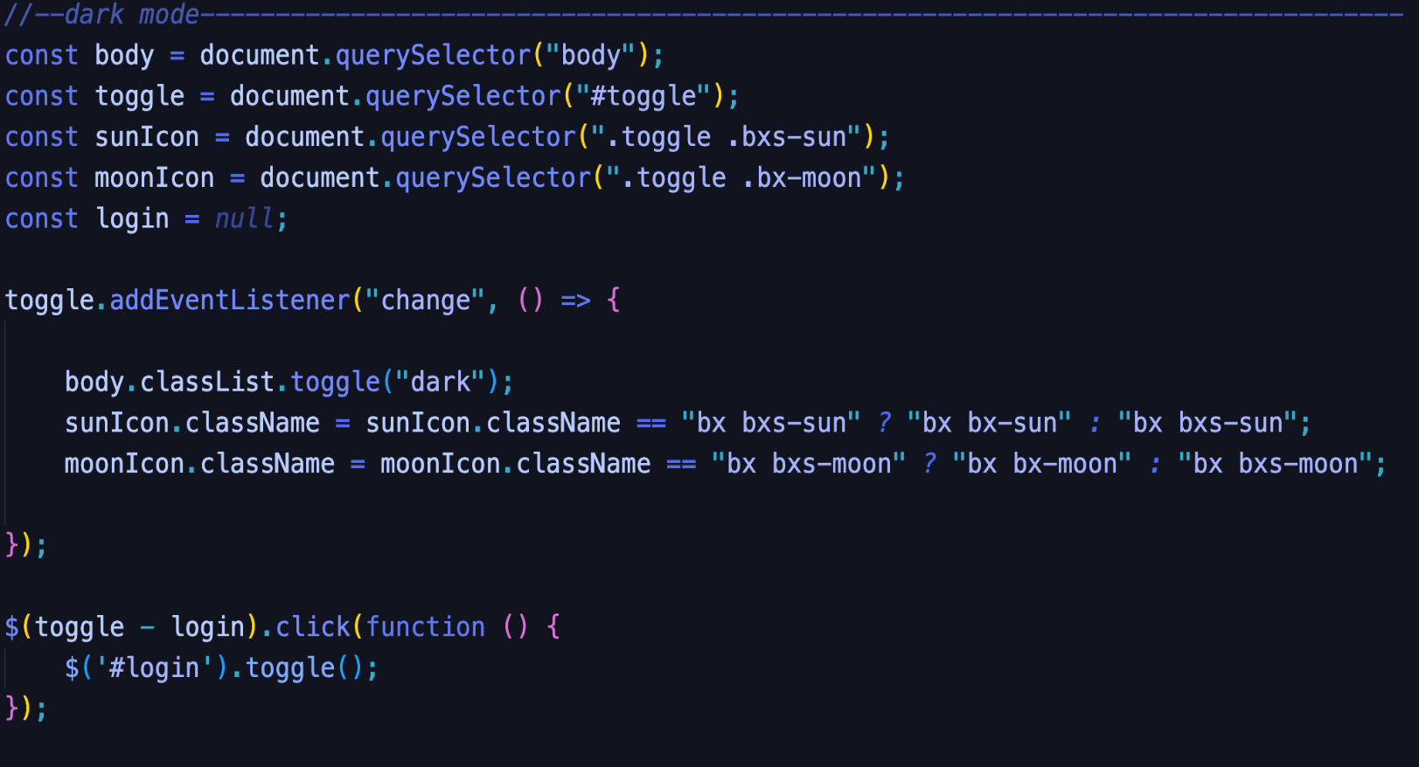

I implemented here an active class for when the user switches between Login/Register.

Also, when the form is completed, by clicking on the button with id: ”#submit” the form is closed.

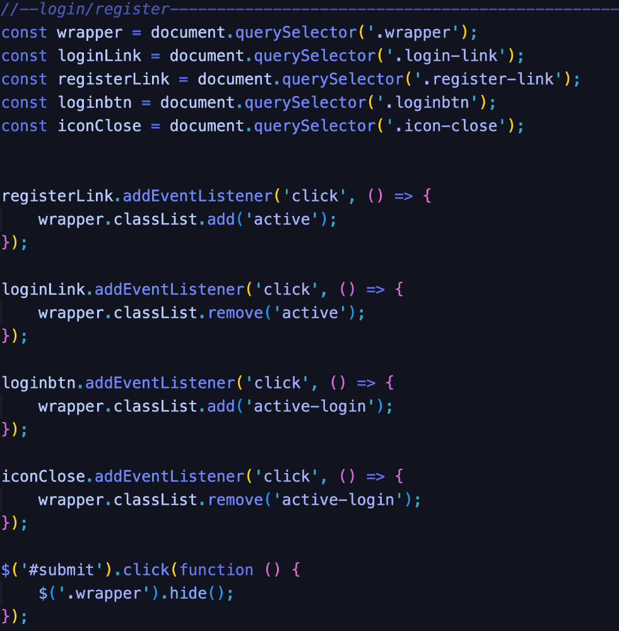

# **7. a) Bibliography**

1. *What is a quiz?*

https://www.jotform.com/blog/quiz-vs-test/

1. *StatCounter Devices usage*

https://gs.statcounter.com/platform-market-share/desktop-mobile-table

3) *StatCounter Browser usage* <https://gs.statcounter.com/browser-market-share>

4)

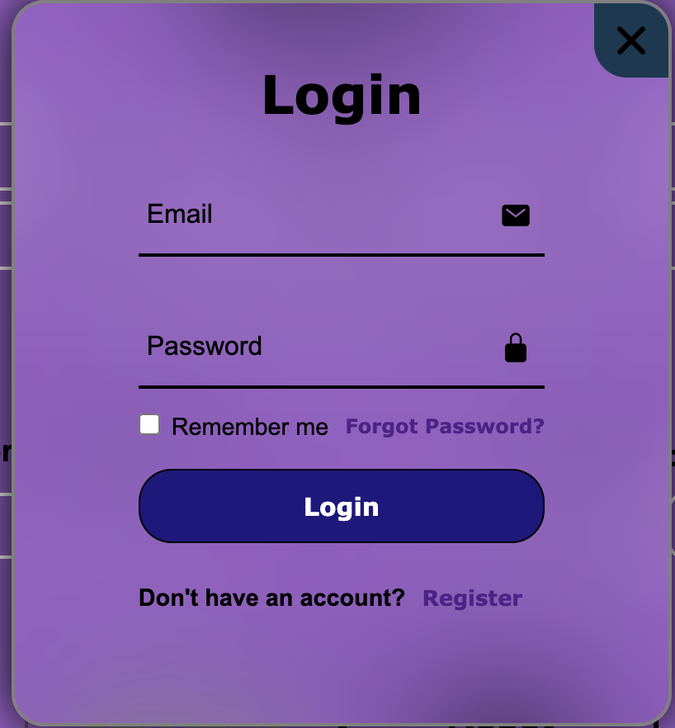On light mode: On dark mode:

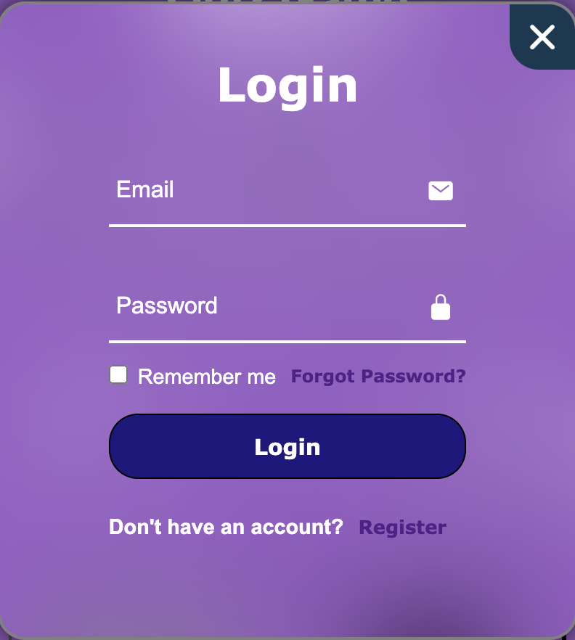

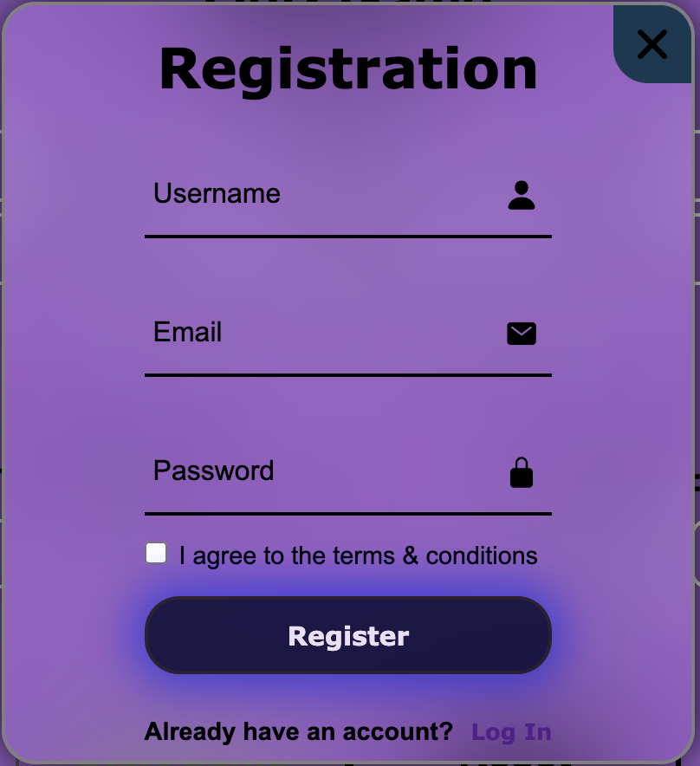

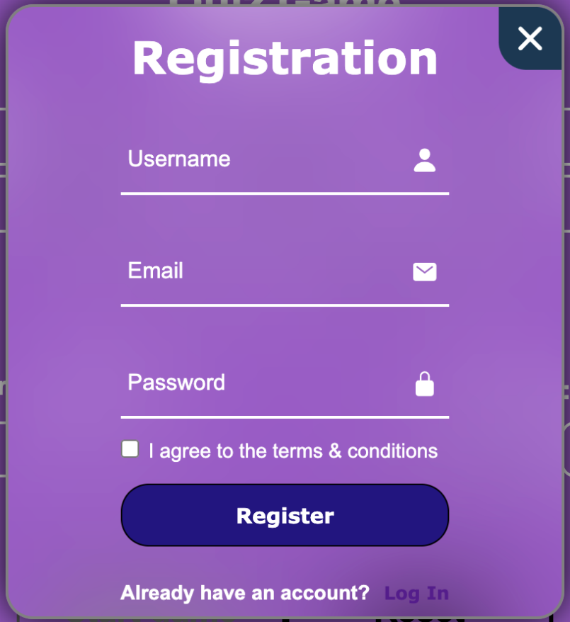

**On light mode:**

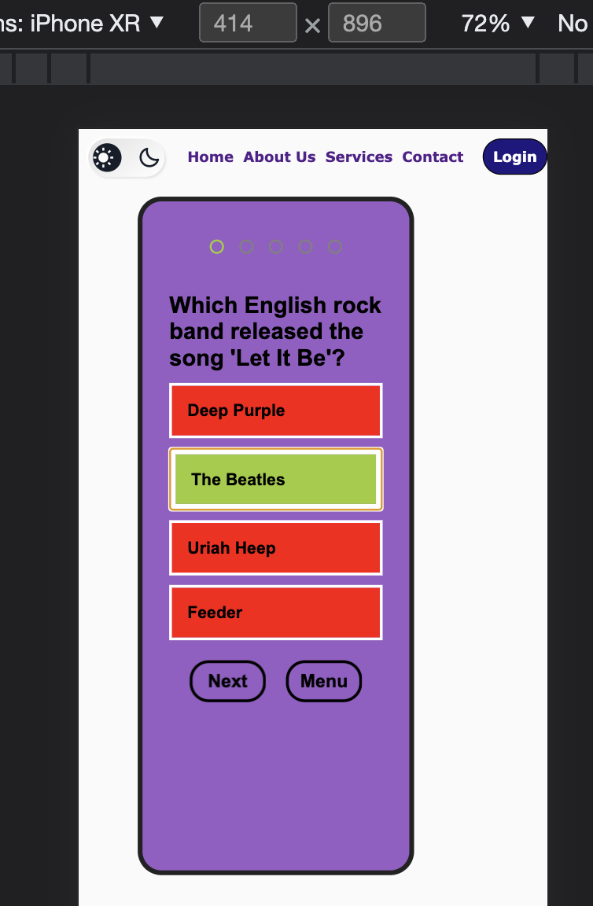

**On dark mode:**



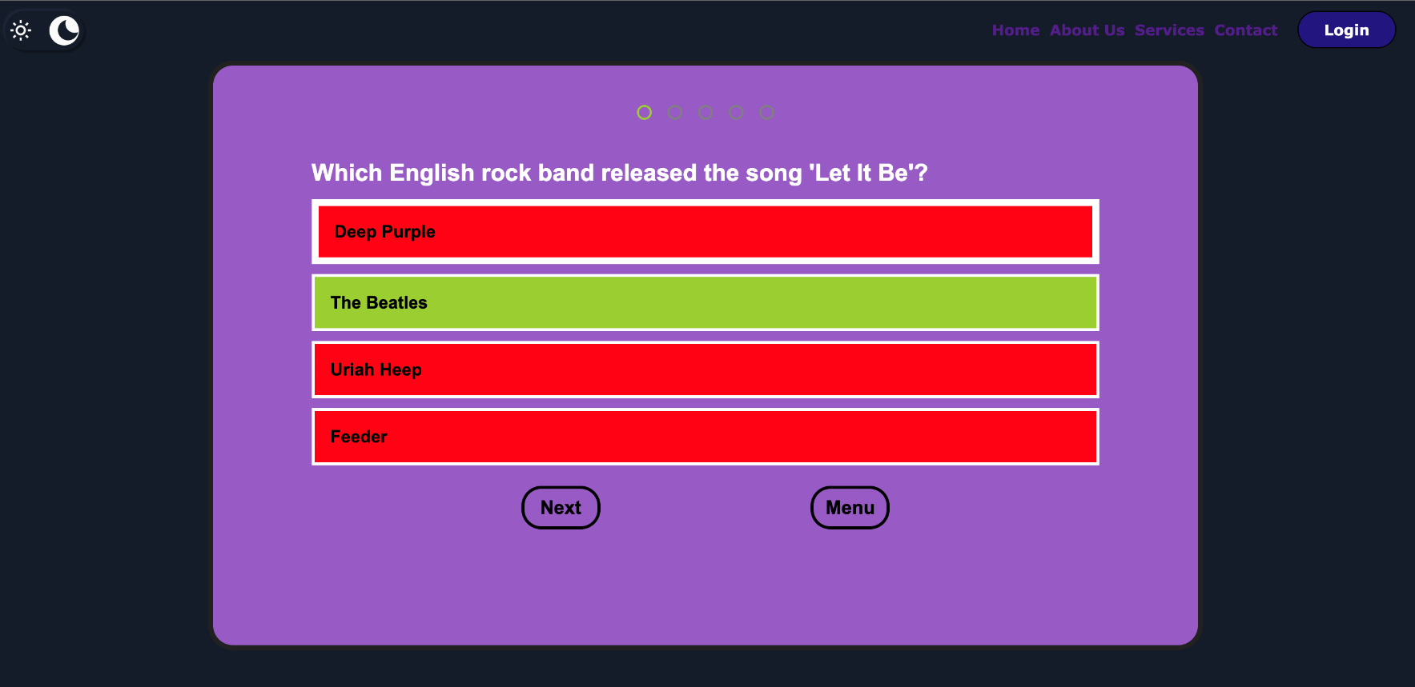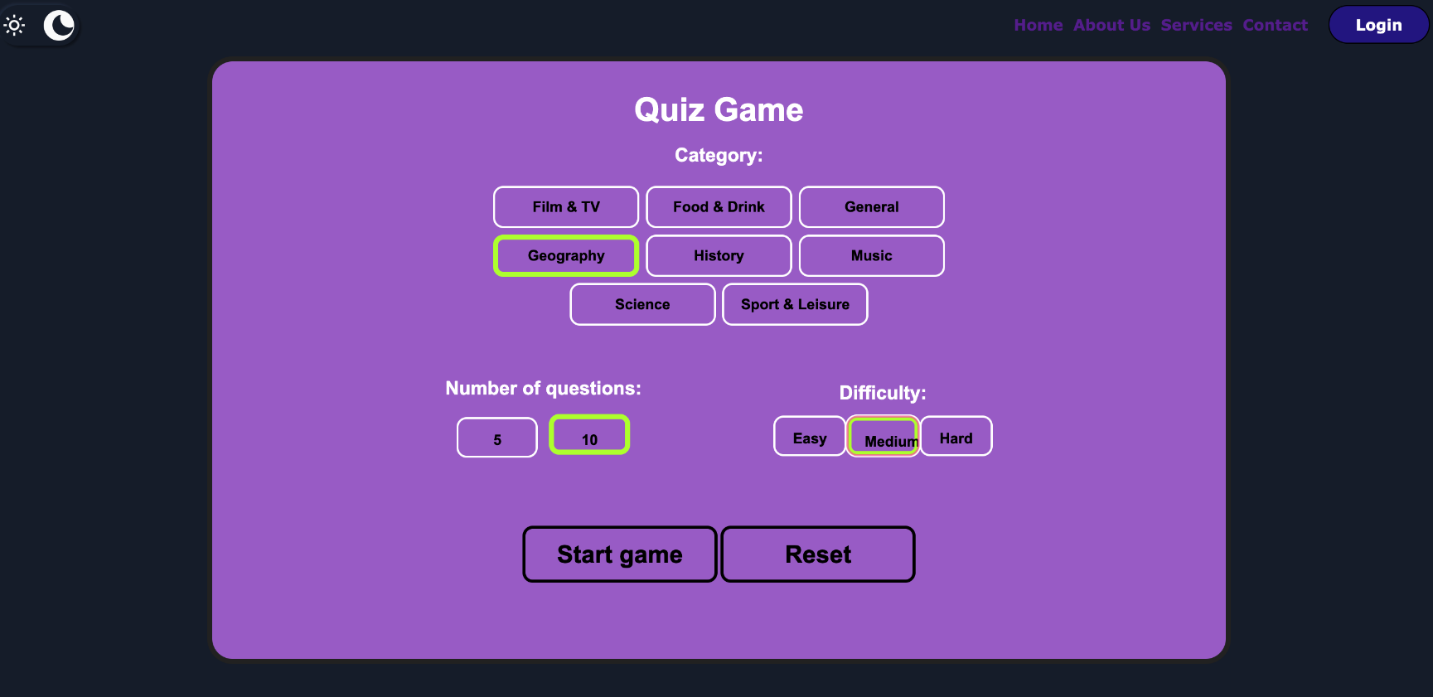

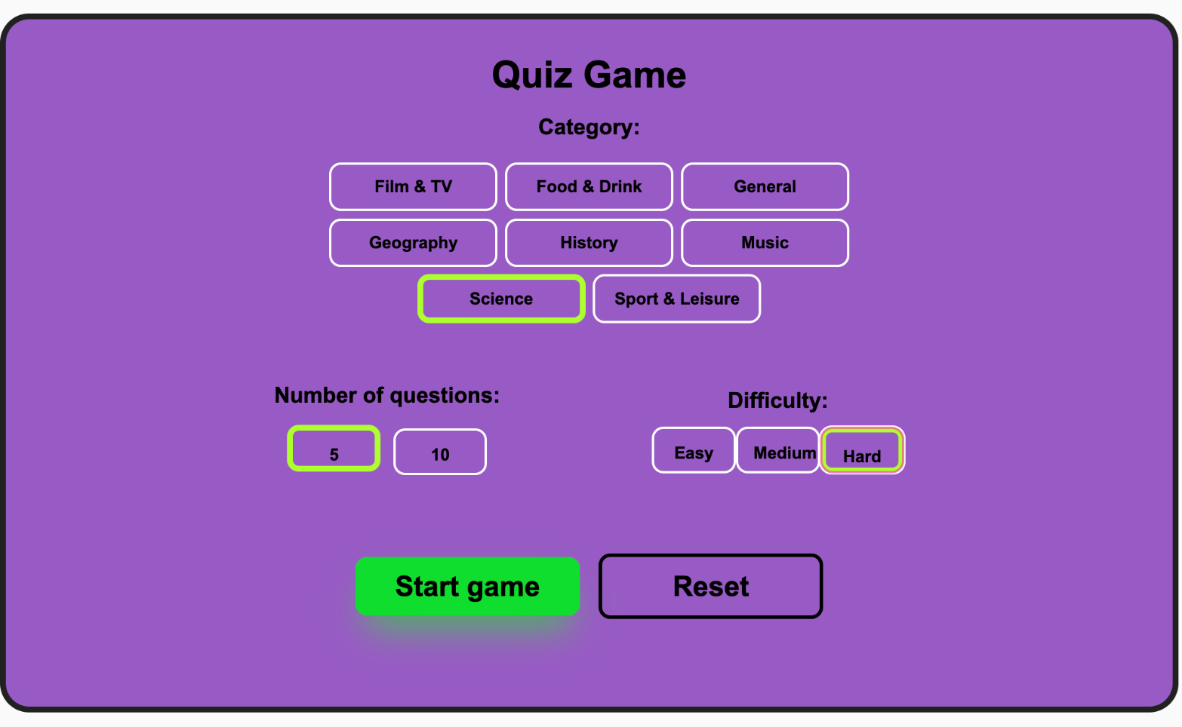  **On light mode:**

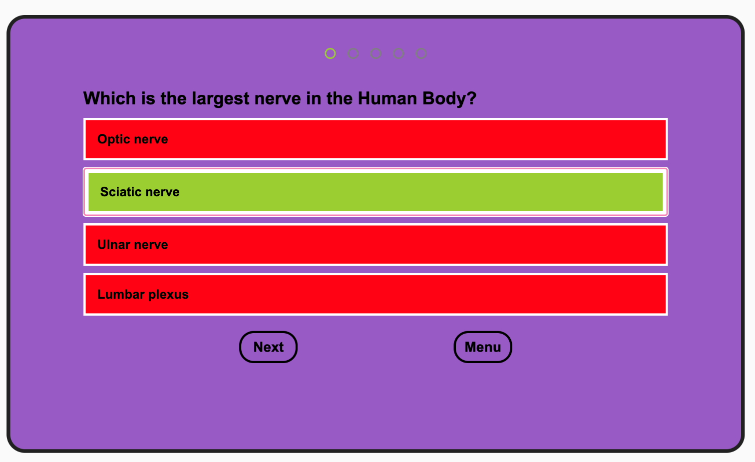

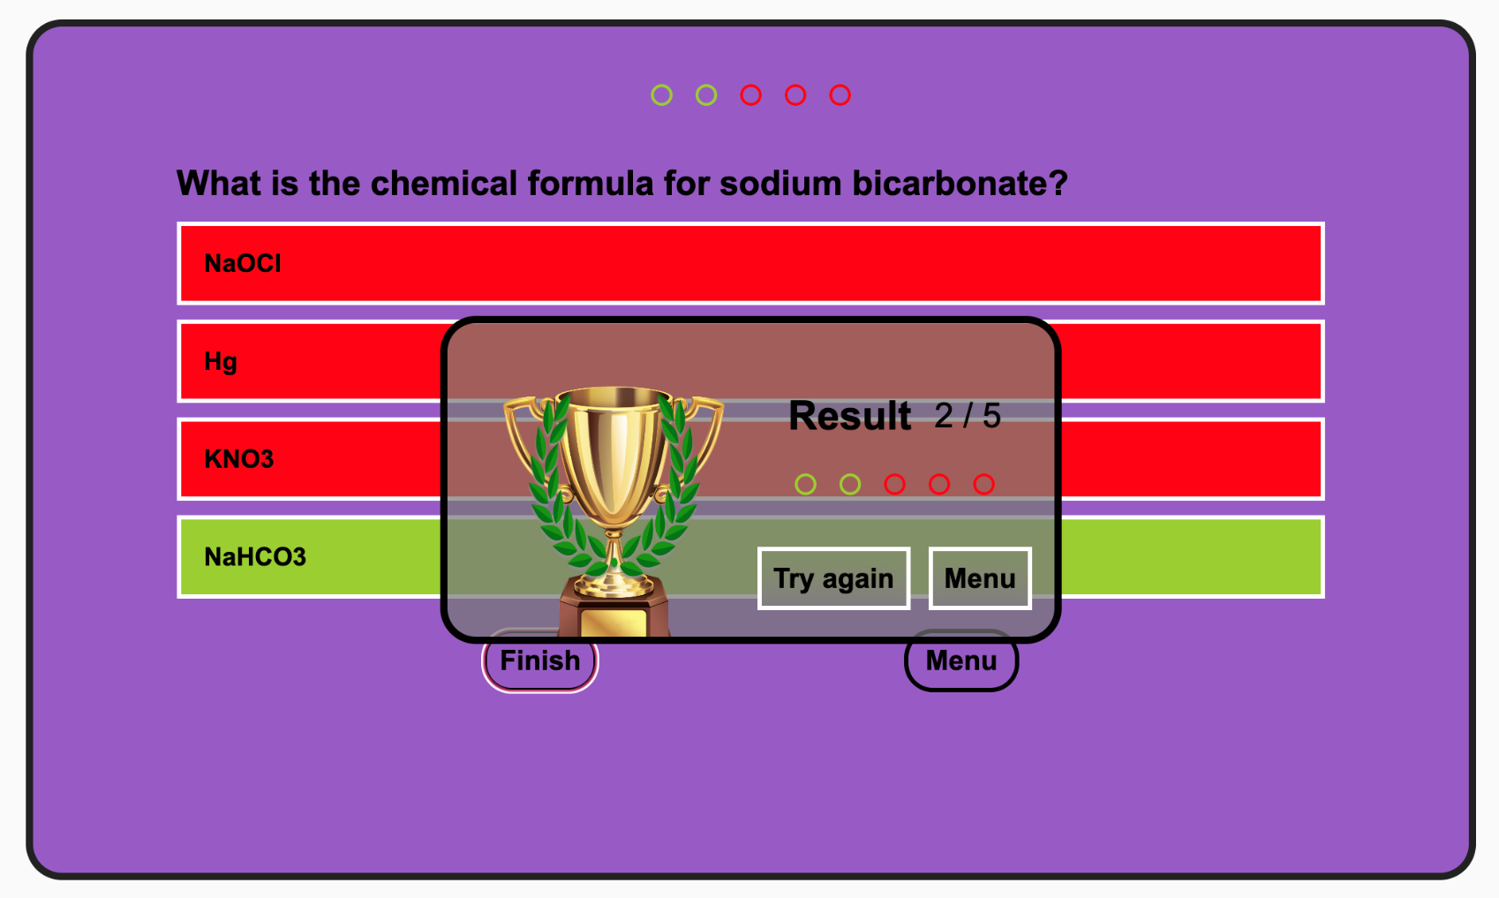

**5. Additional enhancement**

* **Adding another language**
* **Remember me works**
* **User remains logged in**
* **6. Bibliography**

**1) What is a quiz?**

[**https://www.jotform.com/blog/quiz-vs-test/**](https://www.jotform.com/blog/quiz-vs-test/)

**2) StatCounter Devices usage**

[**https://gs.statcounter.com/platform-market-share/desktop-mobile-tablet**](https://gs.statcounter.com/platform-market-share/desktop-mobile-tablet)

**3) StatCounter Browser usage**

**https://gs.statcounter.com/browser-market-share**